Topic: Introduction to IT and Computers
Definition of Information Technology
Information technology is using information technological tools to process and analyze raw data to information.
ROLES OF IT IN Financial engineering
- Running financial models
- Data analysis using Excel, python, R e.t.c
- Risk assessment and simulations
- Automating trading and investment decisions
- Storing and managing financial data
Roles of IT in Society:
Positive impacts:
- IT improves multiple sectors like health care, raising living standards.
- It leads to economic growth, financial engineers use IT to design products that stabilize markets and support businesses.
- Has led to education access, online platforms make financial knowledge available to wider society reducing barriers
- Has led to efficient financial services, IT innovations improve access to finance, i.e(Mobile wallets)
Negative impacts:
- Cybersecurity risks: Risk of fraud and hacking.
- Digital divide: People without IT access are excluded from modern financial services.
- Job displacement: Automation and AI reduce traditional roles in most industries i.e Finance.
Basic computer terminologies
- Computer is a device that takes in input as raw data, stores and transforms it meaningful information.
- Hardware -The physical parts of a computer that you can touch.
Examples: keyboard, mouse, monitor, CPU, hard drive.
- Software -The programs or instructions that tell the computer what to do.
Examples: Windows, MS Word, games, apps.
Types of Software:
- System software – controls hardware (e.g, Operating System).
- Application software – performs user tasks (e.g, browsers, calculators).
Data -Raw facts and figures entered into a computer.
Information -Processed data that is meaningful and useful to the user.
Input Devices -Devices used to enter data into a computer.
Examples: keyboard, mouse, scanner, microphone.
Output Devices -Devices that display or produce information from a computer.
Examples: monitor, printer, speakers.
Historic computing devices include:
- Abacus and Napier’s bones used as calculating devices.
Components of a computer
- · Central processing unit (CPU): The heart of the computer, this is the component that actually executes instructions organized in programs ("software") which tell the computer what to do.
- · Memory (fast, expensive, short-term memory): Enables a computer to store, at least temporarily, data, programs, and intermediate results.
- · Mass storage device (slower, cheaper, long-term memory): Allows a computer to permanently retain large amounts of data and programs between jobs. Common mass storage devices include disk drives and tape drives.
- · Input device: Usually a keyboard and mouse, the input device is the conduit through which data and instructions enter a computer.
- · Output device: A display screen, printer, or other devices that let you see what the computer has accomplished.
Types of computers
- Computers can be generally classified by size and power as follows, though there is considerable overlap:
- · Personal computer: A small, single-user computer based on a microprocessor.
- · Workstation/Laptops: A powerful, single-user computer. A workstation is like a personal computer, but it has a more powerful microprocessor and, in general, a higher-quality monitor.
- · Minicomputer: A multi-user computer capable of supporting up to hundreds of users simultaneously.
- · Mainframe: A powerful multi-user computer capable of supporting many hundreds or thousands of users simultaneously.
- · Supercomputer: An extremely fast computer that can perform hundreds of millions of instructions per second.
High performance Computing (HPC)
Using powerful computers to solve large and complex calculations quickly
Cloud computing: Is accessing storage, software and computing power over the internet e.g Google drive, AWS
COMPUTING APPLICATION IN FINANCIAL ENGINEERING
- In financial engineering, computing is used to build and test financial models, analyze market data and support decision making.
- Tools like excel, python, MATLAB and specialized financial software help in risk analysis, pricing derivatives, forecasting market trends, algorithmic trading and managing big financial data.
- Computing improves accuracy, speed and automation in financial operations.
Topic 2: Fundamentals of computer operations
A computer performs four basic operations known as the IPOS cycle which include inputting, processing, outputting and storing data for future use. These operations are coordinated by the control unit, which directs the sequence of actions, and are executed by the hardware guided by software.
1. Input
The term input refers to activities required to record data hence this is the process of entering data or instructions into the computer system.

Examples of input devices used to send information to the computer are;

keyboard, mouse, scanner, microphone and touchscreen

2. Processing

This is the logical operations where the computer manipulates or works on the input data to produce meaningful information.

Main component:

CPU (Central Processing Unit), which includes:

ALU (Arithmetic and Logic Unit) – performs calculations and logical decisions

CU (Control Unit) – controls and coordinates all operations

3. Output

This is the process of displaying results after data has been processed.

Examples of output devices include;
Monitor, printer, speakers, projector
- It works by using devices like a monitor to display the results visually or use a printer to produce a hard copy.

4. Storage

This is the saving of data and information for future use.

There are two types of data storage which include;

Primary storage: RAM, ROM
Secondary storage: Hard disk, SSD, Flash drive, Memory card

Summary Diagram (IPOS Cycle)
Input → Processing → Output → Storage
An addition on other computer operations:

5. Control
- This is the monitoring and directing of all other operations within the computer system. The Control Unit (CU) directs and coordinates all parts of the computer system.

6. Communication

Computers communicate data and information using networks such as Wi-Fi, Bluetooth, and the Internet.
In conclusion: A computer works using the IPOS cycle: Input, output and storage.
Below is the image;

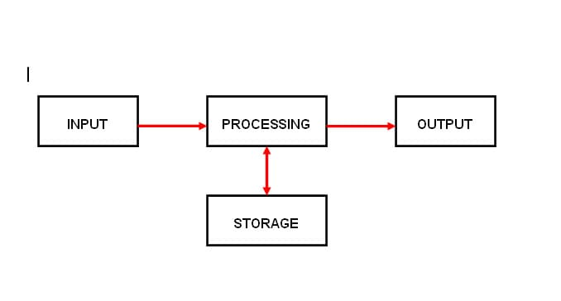
Input devices capture data, the CPU processes it, output devices display results, and storage devices keep information permanently.

Topic 3: Computer Hardwares
It refers to the physical components of a computer
They are dived into various categories.
- INPUT DEVICES
They allow the user to enter data into the computer
EXAMPLES
- Keyboard-typing texts and commands
- Mouse-used for pointing clicking and selecting
- Microphone-it captures sound
- Joystick-it’s used in gaming for controlling movements and navigating.
- scanner-it converts physical documents to digital form

- OUTPUT DEVICES
They display and produce the information that the computer has processed.
EXAMPLES
- Monitor-it displays information visually
- Projector-it displays large images on a wall or a screen
- Speakers-it outputs sound
- Printer-produces hard copies
- PROCESSING UNIT
It’s the computers brain responsible for executing instructions
MAIN COMPONENTS
- Central processing unit (CPU) –it controls all operations and executes instructions given to the computer
- Control unit (CU)-it gives directs and coordinates all the operations inside the computer
- Arithmetic logic unit (ALU)-Performs calculations and logical operations

- PORTS AND CONNECTORS
They are used to connect external devices
EXAMPLES
- USB (universal serial bus) Port-connects devices like flash, printers etc.
- HDMI(High Definition Multimedia Interface)port-transmits high quality audio and videos
- Ethernet port-Connects a computer to a wired net work

- STORAGE DEVICES
These store data temporarily or permanently
They are divided into two categories
PRIMARY STORAGE
- RAM (Random Access Memory)
- ROM (Read Only Memory)
SECONDARY STORAGE
- These include hard disks, flash drives and memory cards and can be used foe long term storage
OTHER INTERNAL HARDWARE COMPONENTS
They are located inside the system unit
EXAMPLES
- Motherboard-connects and allows communication between all parts
- Power supply unit –converts electricity to usable power for computer components
- Cooling systems e.g. fans- keeps the computer from over heating
- Network card- Allows the computer to connect to a network

Topic 4: Computer Software
What is Software?
Computer software refers to the programs and operating systems that run on computer hardware. It enables users to perform tasks, solve problems, and access information. Software is intangible and consists of code that instructs the hardware on how to function.

Types of Software
Software can be categorized into three main types:

1. System Software:
- Includes operating systems (e.g., Windows macOS, Linux), device drivers, and utility programs. It manages hardware resources and provides essential services for application software.

2. Application Software:
- Performs specific tasks for end-users, such as productivity tools (e.g., Microsoft Office, Google Workspace, creative software (e.g., graphic design and video editing tools), and communication software (e.g., email and messaging platforms).

3. Programming Software:
Comprises tools like compilers, interpreters, and integrated development environments (IDEs) to help developers write and test code.

Software Characteristics
Understanding software characteristics is essential:

1. Licensing: Software can be proprietary (owned by a company), open-source (freely available for modification), or freeware (available at no cost but not modifiable).

2. Platform: Software is designed for specific platforms, such as Windows, macOS Linux, or mobile devices.

3. Distribution: Software can be distributed through downloads, physical media, or cloud-based services, making it accessible to users in various formats.

Key Software Concepts
Key concepts in software include:

1. Operating Systems: Manage hardware resources, provide essential services, and run applications to ensure smooth interaction between user tasks and hardware.

2. Applications: Enable users to perform specific tasks, solve problems, and provide various services across different domains.

3. Programming: The development of software using programming languages, frameworks, and tools to create functional applications.

Best Practices
To optimize software use, follow these best practices:

1. Keep Software Up-to-Date: Regular updates ensure security patches, performance improvements, and new features.

2. Check Compatibility: Ensure software works with your system and hardware to prevent operational disruptions.

3. Protect Data: Regularly back up data, use antivirus software to prevent malware, and maintain security protocols.

Popular Software Categories
Familiarize yourself with these popular software categories:

1. Productivity: Office suites, web browsers, and project management tools that enhance workflow and efficiency.

2. Creative: Graphic design, video editing, and digital art software that enable artistic expression and multimedia creation.

3. Communication: Email, messaging, and video conferencing software that facilitate collaboration and interaction.

Compiling Systems and Software Installation
Compiling Systems convert high-level programming languages into machine code. This process includes writing source code, using compilers to translate it, and linkers to create executable files.

Software Installation involves copying software files from a distribution medium to a computer and configuring the software. Key steps include downloading the software, running the installation program, and following prompts to complete the setup.

Utility Programs
Utility programs enhance computer performance through maintenance tasks. These include disk cleanup tools and antivirus software that protect against security threats and optimize system resources.

Hands-On Demo
A hands-on demo could show how to install a simple application, like a web browser, and demonstrate using a utility program for tasks such as disk cleanup to free up space and improve performance.

Topic 5: Data and Data Files
- Data: Raw facts or figures (e.g., numbers, text, images) that have no meaning on their own.
Purpose: Data is what you examine, manipulate, and interpret to draw conclusions. For example, in a study on student performance, "number of hours studied" is a piece of data.
Characteristics of data:
Raw
Unorganized
Has no meaning
Can be quantitative
Types of Data:
- Qualitative – data that describes qualities of characters. Example colors
- Nominal names or labels
- Ordinal categories with meaningful order i.e small, medium, large
- Quantitative – data that can be measured and expressed in numbers.
- Discrete data -countable data i.e 1,2,3
- Continuous data – measurable data that can take value i.e height
- Primary data – data collected directly by the researcher for the first time. Examples Interviews
- Secondary data – data collected by someone else often for a different purpose. Example Government statistics.
- Structured data – organized in rows and columns i.e spreadsheets
- Unstructured data – not organized i.e emails
- Information: Processed or organized data that is meaningful.
Data File
- Data File: A collection of related data stored as a unit.
- Examples: Word documents, Excel files, databases

File Formats:
- .docx for Word
- .xlsx, .csv for Excel
- .db, .mdb for database files
- .jpg for images
- .mp3 for audio

- File Organization: Files are saved in folders/directories for easy access
Types of file organization
- Random files/ Direct Access - Records are stored in such a way that they can be accessed directly without following a sequence.
- Sequential files - Records are stored one after another in a fixed order.

Data storage and organization
Data storage refers to methods and devices used to store data such as hard drives and cloud storage.
Data organization- involves structuring data in a way that makes it easy to access and use. It includes organizing data into folders and creating backups
Data processing techniques
Data processing involves techniques used to manipulate and analyze data.
They include:
Sorting
Filtering
Aggregating: Combining data to produce summaries
Data security measures
They are taken to protect data from unauthorized access or damage.
These can include: Encryption which is converting data into a secure code.
Backups: creating copies of data to prevent loss
Passwords: using passwords.

Data Representation in Computers
Computers represent data using binary codes which consist of only zeros and ones. These binary systems are the foundation for storing and processing information.
They include:
Bits – the basic unit of information represented by either zero or one.
Bytes – a group of 8 bits that represent a single character.
Word – is a group of bytes that a processer can handle efficiently.

Data Types
Integers which are whole numbers
Float which are decimal numbers
Characters which are letters, symbols or special characters.
Boolean are logic values that can be true or false.

Topic 6: DISK STORAGE FUNDAMENTALS
Disk storage is a method of storing digital data on magnetic or optical disk.
Types of disk storage:
- Magnetic: Hard disks drives (HDDs)
- Solid State: SSDs, flash drives
- Optical: CD
Components/structure of a disk storage device
- Platters -round, rigid disks coated with magnetic materials (in HDDs)
- Heads -Read/write heads that access data on platter
- Actuator -A mechanical component that moves the heads across the platters
- Controller -that manages the disk operations
- Cylinders- a collection of tracks at the same radial position on multiple platters.
- Tracks- circular path on a disk where data is stored
- Spindle – rotates the platters
- Sectors- small sections of a track that stores a fixed amount of data
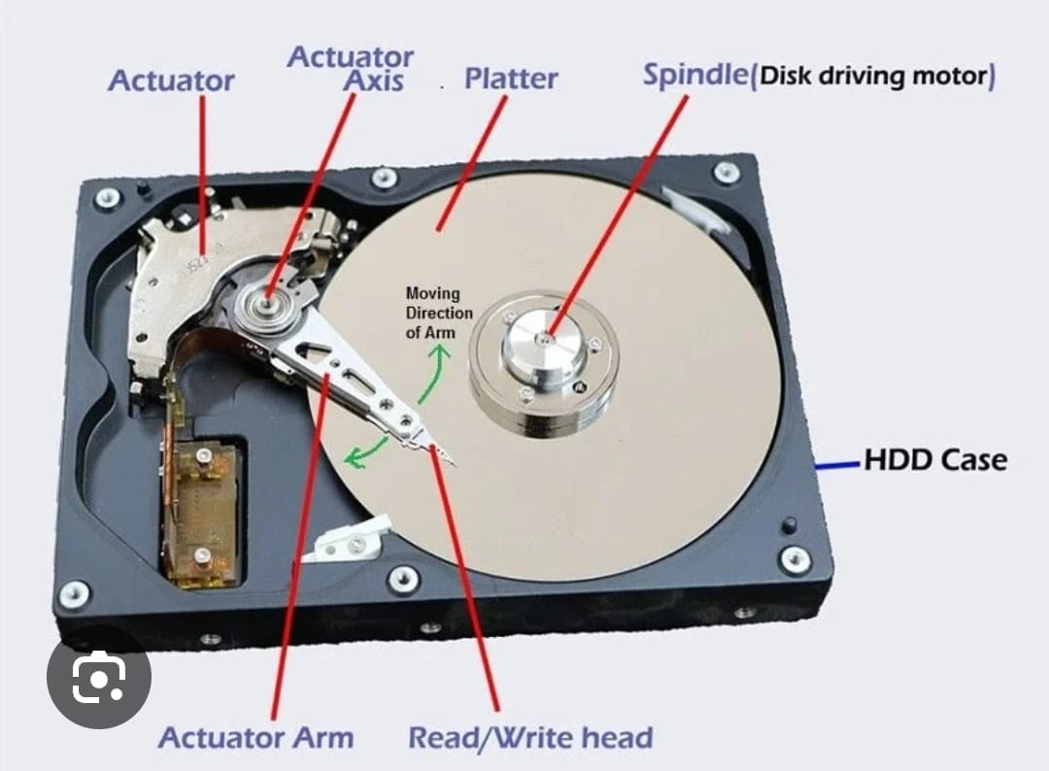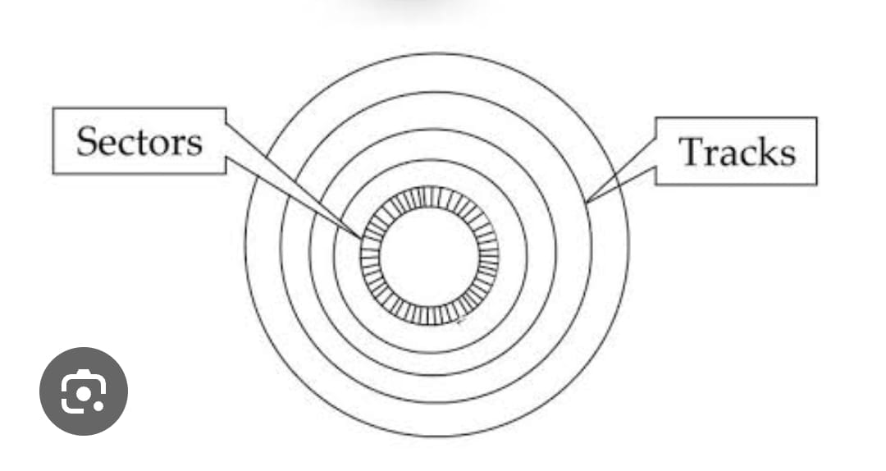
Data organization and storage
Data on a disk is organized into
- Tracks- circular path on a disk where data is stored
- Sectors- small sections of a track that stores a fixed amount of data (usually 512 bytes)
- Cylinders- a collection of tracks at the same radial position on multiple platters.
Types of disk capacities
- Bytes(B) – a single character or number
- Kilobytes (KB)- 10³
- Megabytes (MB)- 10⁶
- Gigabytes (GB) - 10⁹
- Terabytes (TB) - 10¹²
- Petabytes (PB)- 10¹⁵
Factors affecting disk capacity
Storage density- amount of data that can be stored per unit are
Number of platters- affects the overall capacity.
Track and sector density- they determine the capacity.
CLUSTERS
Is a group of contiguous sectors on a disk treated as a single unit of data storage and retrieval. They are used to organize data on a disk and improve efficiency.

